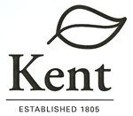
Manager’s Communication

January 16, 2015

Life outside the lines.

Unauthorized Items

1. Donation from the Christenson Foundation (Draft #15-04)

The Henry V. & Frances W. Christenson Foundation has pledged a donation of $1,500 in support of the Kent Adopt A Spot program.

Administration Recommendation
I recommend Council accept the donation.

Council Action
Authorize acceptance of the donation.

2. Donation from the American Legion Portage Post #496(Draft #15-05)

As a result of the new Kent Parks and Recreation Bingo Program operated by the American Legion Portage Post #496, the American Legion is donating last month's proceeds ($692.10) raised from the bingo games to Kent Parks and Recreation.

Administration Recommendation
I recommend Council accept the donation.

Council Action
Authorize acceptance of the donation.

3. Donation from the Portage County Drug Task Force (Draft #15 -07)

Police Chief Michelle Lee has asked for Council’s authorization to accept the donation of a 2014 Dodge Journey sport utility vehicle (valued at $18,000) offered by the Portage County Drug Task Force. The vehicle was confiscated in the course of the Task Force’s work and they have offered to donate it to the City for Police operations.

Administration Recommendation
I recommend Council accept the vehicle donation.

Council Action
Authorize acceptance of the vehicle donation.

4. Police Station Land Purchases (Drafts #15-15, 15-16, 15-17)

Jim Silver is requesting Council’s authorization to purchase 3 properties included in the new Police Station project. The properties include 14 Tonkin Court at $137,500; 224 College Avenue at $176,500; and 228 College Avenue at $270,000.

Administration Recommendation
Jim has negotiated prices and contract terms consistent with the guidance provided by City Council and I recommend Council’s support.

Council Action
Authorize approval of the land purchase agreements.



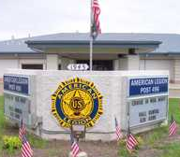



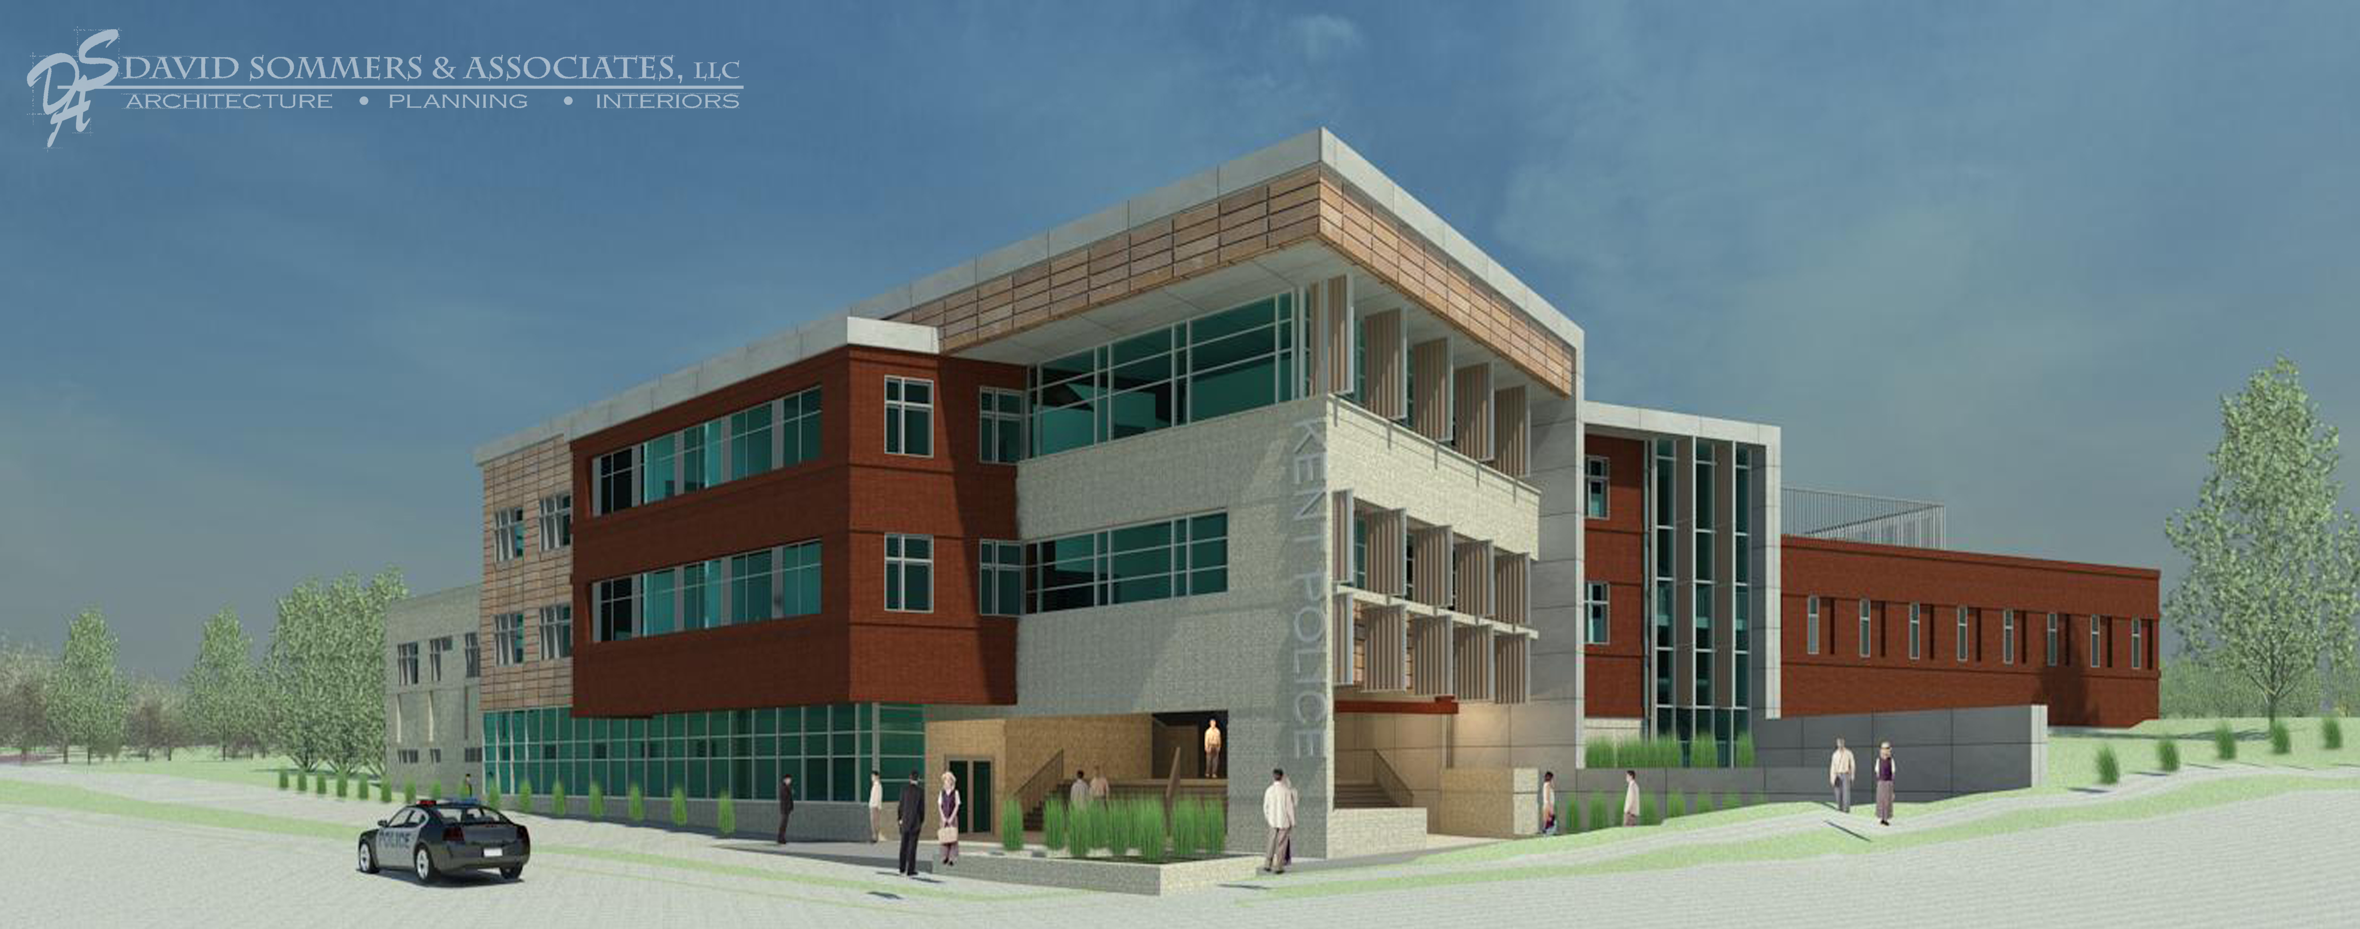

Information Items

1. Monthly Permit and Zoning Reports
Bridget Susel has enclosed copies of the monthly zoning and permit violations report for December 2014. Permit revenues were $86,881 for the month with the most permits being issued for residential plumbing (16 permits). There were 51 code enforcement items in December, most of which were related to property maintenance. (attachment)

2. Summit Street Construction Easements
Jim Bowling has submitted 8 more temporary right of way purchase agreements that Linda has prepared for approval by Council by Ordinance. The terms of the agreements are consistent with the blanket approval policy previously authorized by Council for this project. (attachments)

3. 2105 CDBG Grant Program Schedule

Dan Morganti has provided an outline of the dates and meetings for the development and passage of the 2015 CDBG program for your information. Dan notes that this year's CDBG process includes both the City's new 5-year Consolidated Plan covering PY2015-2019 and the PY2015 Annual Action Plan. The Community Development Department will be issuing an RFP on January 23rd to solicit proposals for PY2015 projects. For PY2015, we anticipate a funding level close to what the City has received the past few years, or around $270,000.

Below are a few key dates associated with the planning process that have already been scheduled through the Clerk of Council:
- February 18, 2015 at 7:25 pm - First public hearing.
- March 4th - Council Committee hears staff recommendations on the City's 5-year Consolidated Plan objectives and specific PY2015 projects. CD will have a memo to you by Wednesday, February 25th outlining recommendations.
- May 20, 2015 at 7:25 pm - Second public hearing.

4. City Consolidated Investment Portfolio Report

Dave Coffee and Brian Huff have shared the City investment consolidated portfolio report as of December 31, 2014 for your information. We currently use Meeder to manage nearly $9 million of our total portfolio which is just short of $25 million. The other $16 million we independently purchase through our brokers.

Brian notes that all of our investments meet the Ohio Revised Code requirements (Section 135) and our City investment policy. Dave and Brian have worked hard to invest as much money as possible in the best spread of investments possible while maintaining the sound principles of safety, liquidity, and yield in that order. At the end of 2014 and heading into 2015 we finally saw some small increases in our interest revenue. Interest rates are still at record lows so the amount of interest revenue is limited by what the market allows. Low interest rates means it’s a great time for the City to borrow money but not for interest revenue. (attachment)

